NAME: S RUPESH
REG NO:- 192571055

DOCKER EXPERIMENTS
EXPERIMENT - 16
AIM:
Create a Static Website and Containerize, Build & Serve it using Docker.

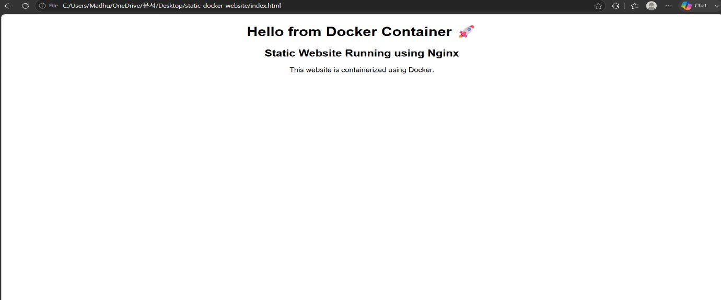
EXPERIMENT – 17
AIM:
Create a Simple Python Flask API, Containerize the Application, Build & Push the Image using Docker and Deploy the Application using Kubernetes.

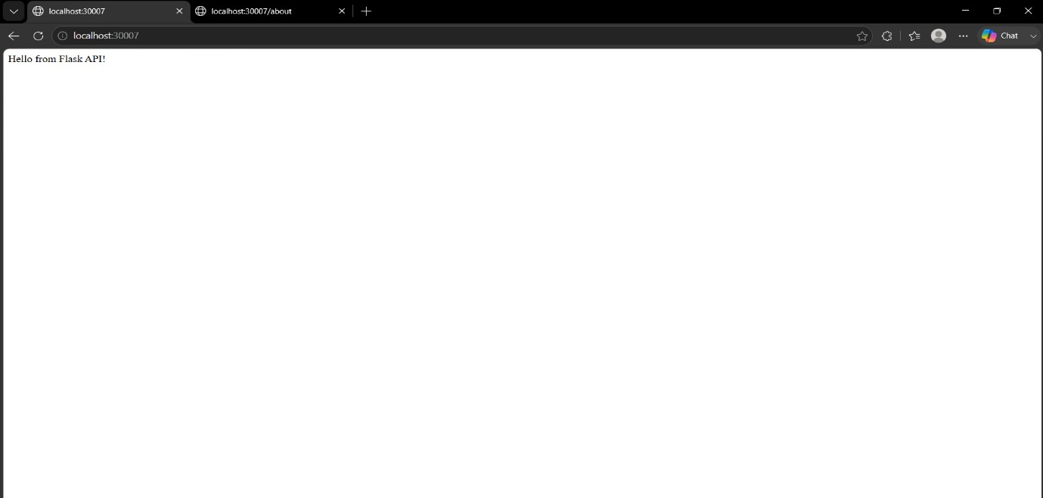

EXPERIMENT- 19

AIM:
Implement Continuous Deployment using GitHub Actions to deploy a Dockerized application.

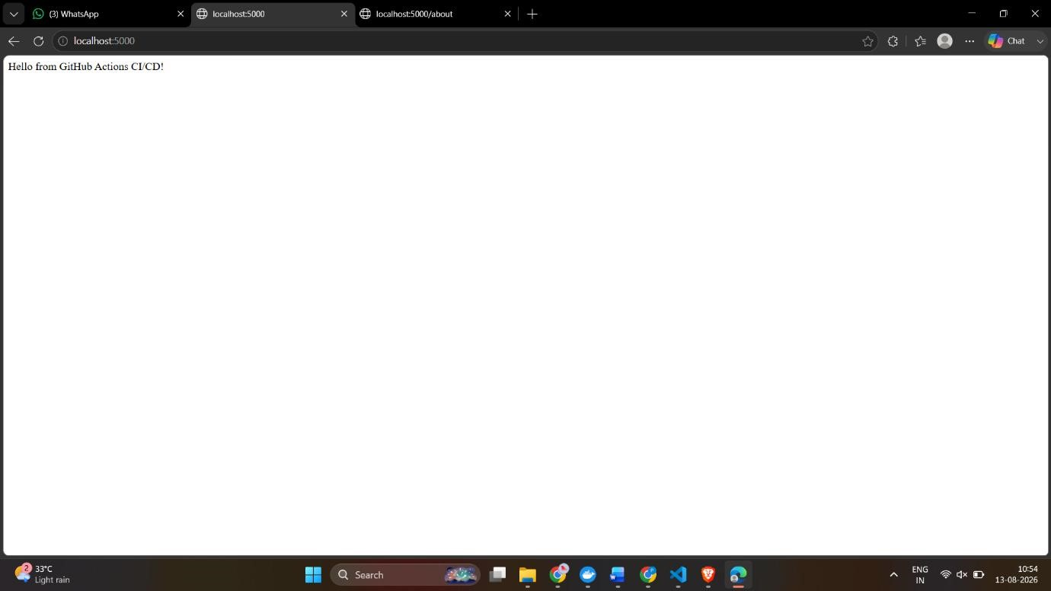

EXPERIMENT- 21

AIM:
Containerize a Python Flask Application Using Docker

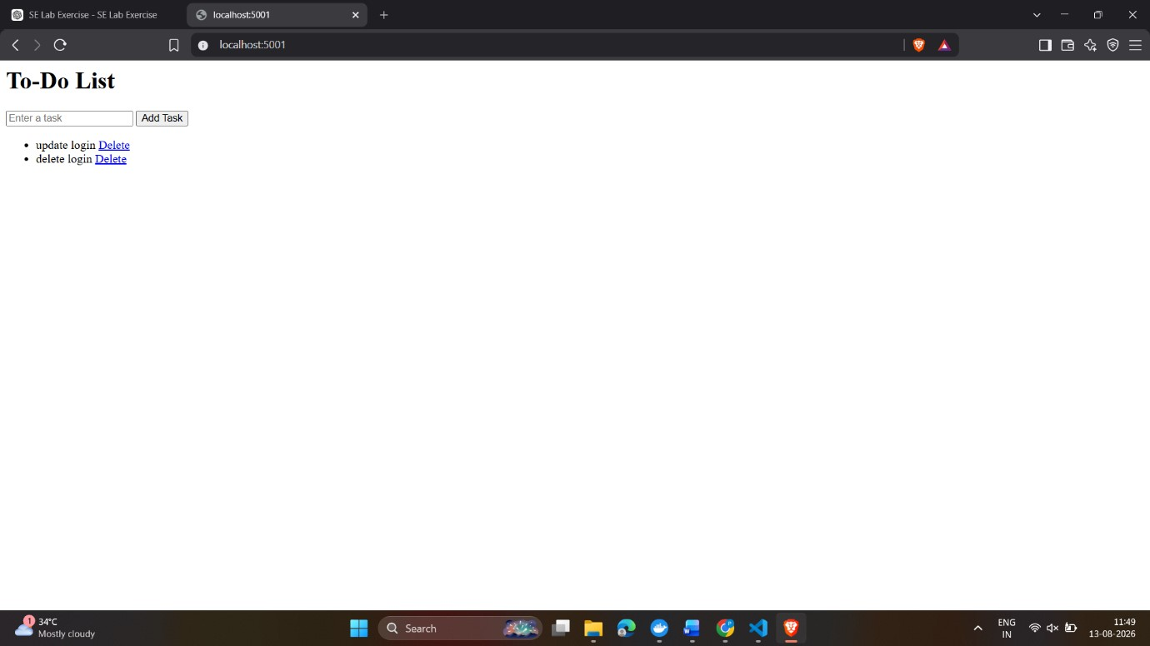

EXPERIMENT- 22

AIM:
Push and Pull Docker Images Using Docker Hub

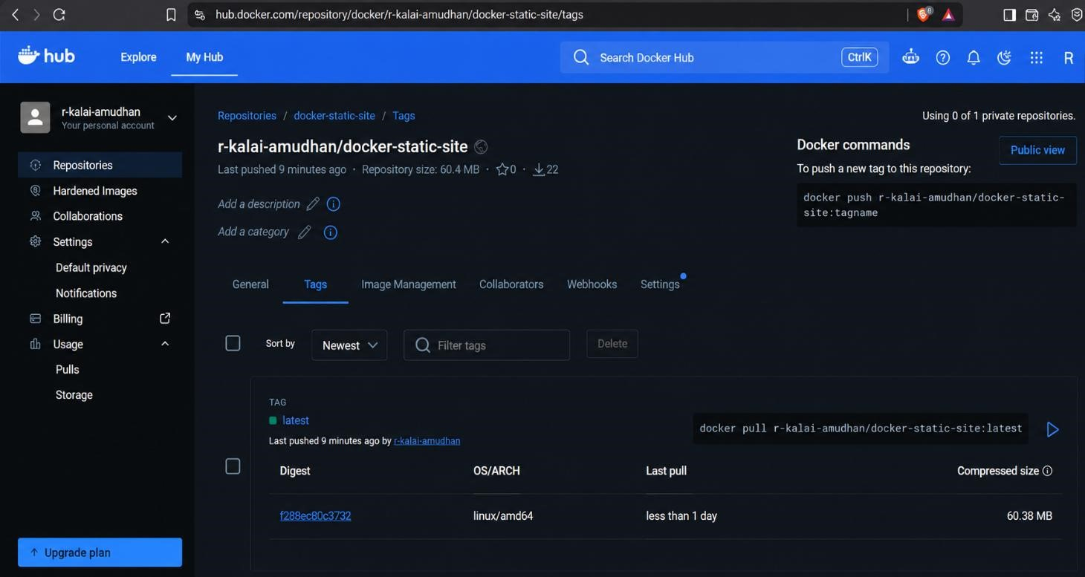

EXPERIMENT- 23

AIM:
Deploy a Multi-Container Application Using Kubernetes
